**Home Page Text Requirements**

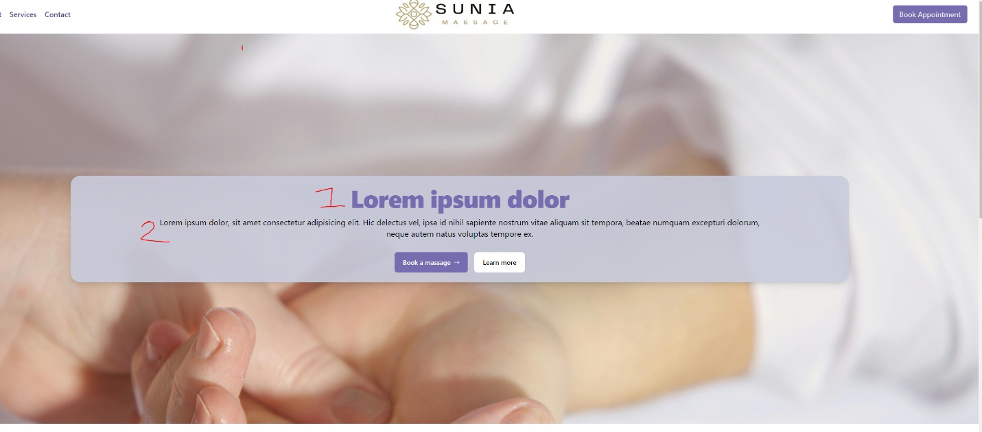Please detail what text you would like for each section or if you would like to keep what is currently being used.

**Jumbotron**

1. **Heading:**
2. **Paragraph:**

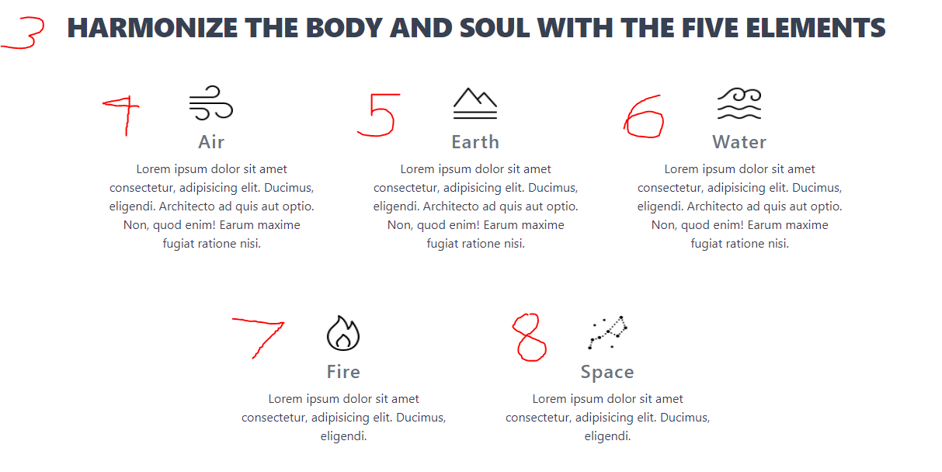

**Element Panel**

1. **Heading:**
2. **Air paragraph:**
3. **Earth Paragraph:**
4. **Water Paragraph:**
5. **Fire Paragraph:**
6. 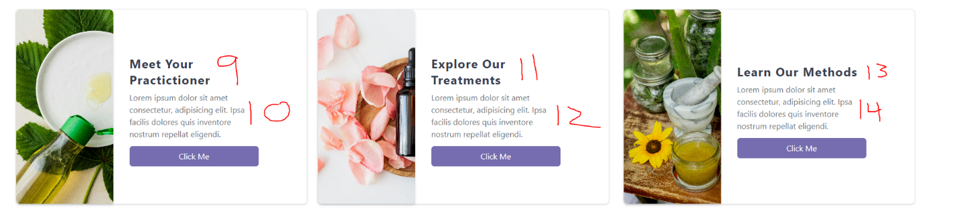**Space Paragraph**

**Hyperlink Cards:**

1. **Header:**
2. **Paragraph:**
3. **Header:**
4. **Paragraph:**
5. **Header:**
6. **Paragraph:**

**Appointment Panel:**

1. **Header:**
2. **Paragraph:**

**Footer**

1. **Address/phone number:**
2. **Hours:**